9.68: a)

c)

d)
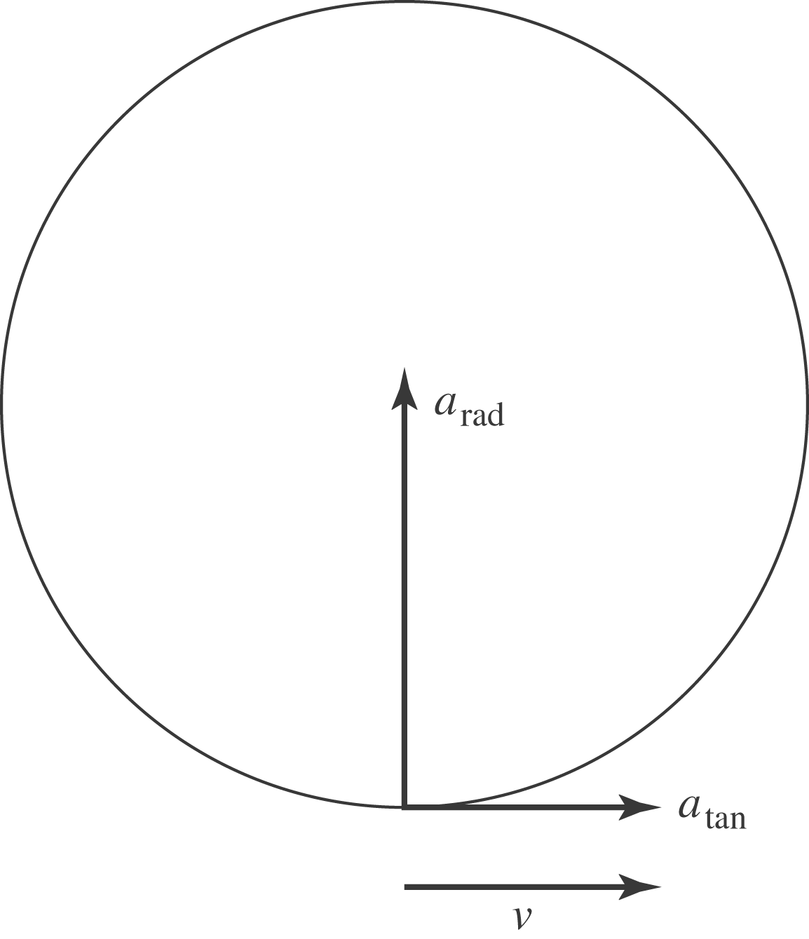

e)
and the magnitude of the force is

f) arctan 